Easter/Resurrection of the Lord March 27, 2016

GATHERING
Announcements and Greeting
Prelude: “Alleluias” Robert Lau
Invocation

*Call To Worship

Leader: Did you not hear? The Lord is alive!
People: Thanks be to God!
Leader: Let us not seek the living among the dead.
People: Christ is risen!
Leader: Christ is risen, indeed!
People: Alleluia, alleluia!

*Hymn: #232 “Jesus Christ Is Risen Today”

Prayer of Confession (Unison)

God of steadfast love, Christ died so that we might live. In his rising, he conquered the many ways of dying. And he wills that we walk in newness of life. Oh, but Lord, we do not leave our tombs. Our fears and doubts still master us. In our hurt and in our hurting others, we die to the self you created us to be. Have mercy, dear God. Remember us. Help us to rise with Christ. Amen.

Assurance of Pardon
*Gloria Patri

PROCLAIMING GOD’S WORD

Anthem: “Christ Jesus Is Arisen” Michael Burkhardt
Chancel Choir
Prayers of the People
First Scripture Readings: Psalm 98 (p.521); Ezekiel 36:26 (p.758)
*Hymn: #238 “Thine Is the Glory”

Children’s Sermon

Second Scripture Reading: John 20:1-18 (p.108)

Sermon: ROLLING AWAY THE STONE
A Tomb at Dawn
Anthem #2: “He Is the Risen Lord” Joseph Martin
Chancel Choir
Named and Claimed
Anthem #3: “Alleluia! Christ Is Risen!” setting Hal Hobson
Chancel Choir

The Easter Angel

RESPONDING TO GOD’S WORD

Affirmation of Faith—Nicene Creed (p.34)

Offering of Tithes and Gifts
Please sign and pass the Friendship Book
Offertory Meditation or “I Know That My Redeemer Liveth” Young/Handel

*Doxology (page 592)

*Hymn: #233 “The Day of Resurrection”
*Benediction
Choral Response – Christ, We Do All Adore Thee DuBois
Chancel Choir
Silent Prayer (be seated)
Postlude “Alleluia! Alleluia!” arr. Dick Torrans
The End of Worship
The Beginning of Service

*Those who wish may stand

As you leave worship, greet all with the Peace of Christ
Rev. Robert W. Birch, Minister
Mrs. Dianne Yuninger, Organist/Choir Director

VISITORS AND MEMBERS: WELCOME! During the offertory the Friendship Book will be passed from the end of the pew. Please sign it and indicate other information as appropriate. Pass the book back down the pew and notice the names of the other worshippers. Greet one another warmly after the service.

WORSHIP HOUR INFORMATION:
It is an ancient Scottish custom for the pulpit Bible to be brought into the sanctuary and placed by a layperson before the service begins.

IN THE NURSERY (babies through 4 yrs.)
9:30 – Tom & Vicki Burkins
IN THE NURSERY (babies through 4 yrs.) next Sunday, April 3
8:00 – On call list 10:30 – Dick & Debbie Sindall

PRAYERS OF THE CONGREGATION:
PRAYER PERSON THIS WEEK: Helen Sharpe

TODAY
6:45 a.m. Easter Dawn Service at Old Leacock
9:30 a.m. Service of Worship Paradise
WEDNESDAY
6:30 p.m. Bell Choir
THURSDAY
5:30 p.m. Community Meal-
6:30 p.m. Worship Committee
7:00 p.m. Acts 16:5 & Worship Committee

OTHER ANNOUNCEMENTS
Today is the last Sunday we will be collecting the One Great Hour of Sharing offering. Please find the envelopes in the church pews or in your envelope box. Let’s share with others what we have been so bountifully given.

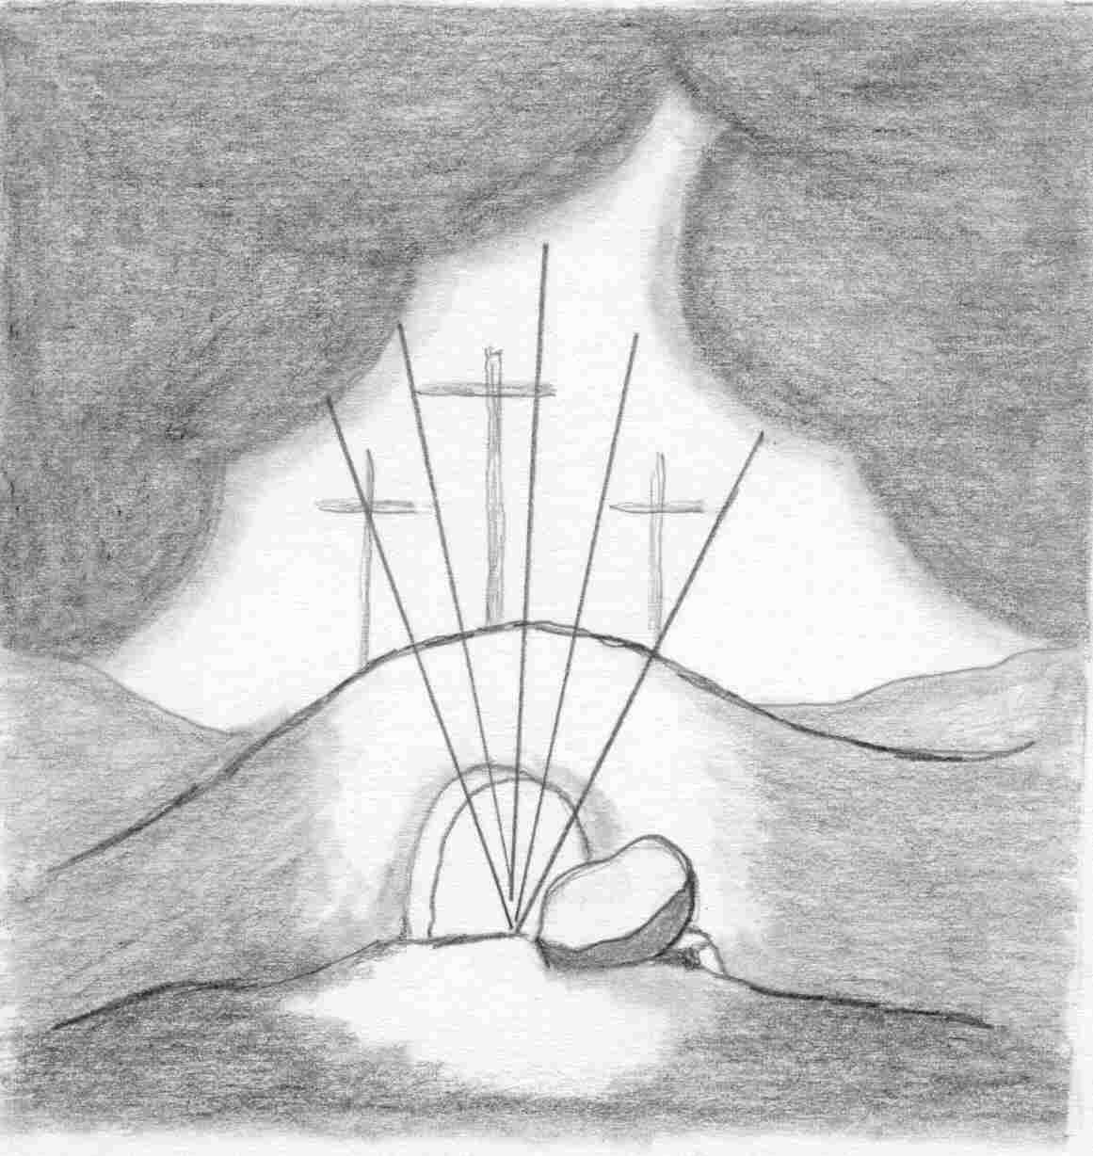

EASTER SERVICE
LEACOCK PRESBYTERIAN CHURCH
MARCH 27, 2016

“Why do you look for the living among the dead?
He is not here, but has risen.”
Luke 24:5

TRUSTEES SPECIAL FUND collected in February put us over the top to get the Manse furnace replaced. We will be looking into the replacement as soon as possible. Thanks to everyone for your support. If you see something that needs the Trustees attention please tell one of us. Thank you. David Berkhimer

The Necklace Class scheduled for Saturday, April 2 is filled. Those who signed up are looking forward to making their own necklace!

Sign-up sheets for the March free Community Meal are in the narthex. Please check and see how you can be of help in the providing of this meal. Thank you for all your support.

During the month of April the Mission Committee will be collecting clean, gently used clothing to donate to the Lancaster County Council of Churches clothing bank. Please put donations in the narthex and the mission committee will take care of it.

The Factory Ministries invites you to The Annual Spring Banquet “Building a Legacy: Living today to impact tomorrow." Join us on April 12, 2016, 6:30PM, at Paradise Elementary School 20 North Belmont Road, Paradise, PA 17562, as we rally to build a legacy that lasts! The Banquet will include a family style meal prepared by our Amish friends, Director’s update, and news of what’s happening in our community.

3/27/2016

